INSTALLATION OF

700 SERIES CARTRIDGE

ROSEDALE PRODUCTS, INC.



PLATINUM 700 SERIES ELEMENT
FOR
150 PSIG RATED CARTRIDGE FILTER UNIT

Table of Contents

I. Installation 2

II. Filter Parts Diagram 3

I. Installation

Your Platinum 700 Series Cartridge Element is used in many filter configurations and filter styles. Please note that this instruction manual gives general information for the installation of the Platinum 700 Series cartridge.

When it becomes necessary to install or replace the cartridge element(s), follow the procedure outlined below:

1. First close the flow from the inlet service line.
2. Close the flow to the outlet service line. (In some applications closing flow to outlet is not required.)
3. Relieve the pressure from the filter unit.

4. Drain housing sufficiently if previously used. Use dirty drain port to lower fluid level below cartridge cup level. (Not required for new vessels).
5. Remove cover by loosening closure assemblies sufficiently to allow them to swing free. Swing cover away from housing to gain access to filter cartridge(s).
6. Remove cartridge element(s) and throw away.
7. Remove debris and sludge from inside the inlet portion of housing to avoid interference with cover seal or flow of fluid being filtered.
8. All 700 series cartridge vessels are equipped with V-posts to help guide filter element(s) into each cartridge cup. Verify V-post is fully seated in cartridge cup located at the bottom of the unit. The V-post bottom horizontal fins will be seated on machined surface in cartridge cup.
9. We recommend pre-wetting the double o-rings at the end of the 700 series cartridge with clean, identical fluid being filtered for ease of installation.
8. Carefully lower the cartridge element(s) over V-post(s). Once each cartridge element is piloted into the cartridge cup, the cartridge element should be pressed in approximately 1". When the cover is closed, there is a minimum clearance that will prevent the cartridge(s) from “pop-up” during operation.
9. Inspect cover gasket for cuts or other signs of failure and make sure it is properly seated.
10. Move cover back into position, close cover and alternately tighten the closure assemblies evenly to ensure a leak proof seal between cover and housing body.

Your Rosedale PLATINUM 700 Series Element Filter unit is now ready for operation.

Filter Parts Diagram

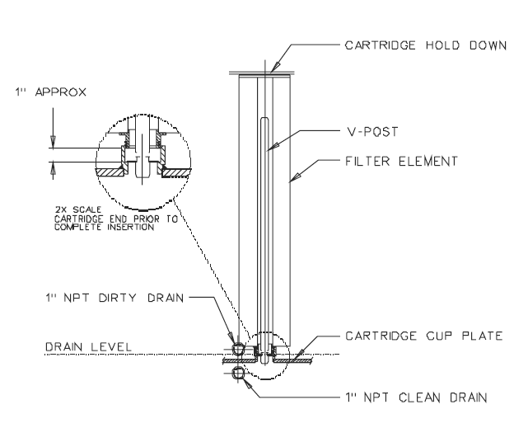

Important Notice

Warranty: In the event any Rosedale Products, Inc. filtration product is found to be defective in material, workmanship, or not in conformance with any express warranty for a specific purpose, Rosedale's only obligation and your exclusive remedy, shall be to repair, replace or refund the purchase price of such parts or products upon timely notification thereof and substantiation that the product has been stored, maintained and used in accordance with Rosedale's written instructions.

EXCLUSIONS TO WARRANTY: THIS WARRANTY IS EXCLUSIVE AND IS IN LIEU OF ANY IMPLIED WARRANTY OF MERCHANTABILITY, FITNESS FOR A PARTICULAR PURPOSE OR OTHER WARRANTY OF QUALITY, EXCEPT OF TITLE AND AGAINST PATENT INFRINGEMENT.

LIMITATION OF LIABILITY: Except as provided above, Rosedale shall not be liable or responsible for any loss or damage, whether direct, indirect, incidental, special or consequential, arising out of sale, use or misuse of Rosedale filtration products, or the user's inability to use such products.

THE REMEDIES SET FORTH HEREIN ARE EXCLUSIVE.

Rosedale Products, Inc.
3730 West Liberty Road
Ann Arbor, MI 48103 USA
734-665-8201
800-821-5373
Fax. 734-665-2214
filters@rosedaleproducts.com
http://www.rosedaleproducts.com

